User Manual

Inventory Management System

Kyle Parker

Christopher Andrews

Chaitanya Chakka

Erik Wojcik

Sarim Janjua

Mohib Ahmed

Nick Turner

Quentin Terry

Table Contents

1. Introduction
2. Overview
3. Startup and usage
   1. Login
   2. Home Screen
   3. Dashboard

3.4.1. Orders

3.4.2. Shippers

3.4.3. Suppliers

3.4.4. Customer

3.4.5. Natural language search

Introduction:

The IMS (inventory management system) app is a user-friendly mobile version of the Inventory management system website. This mobile app will have many of the same options and overall functionalities of the website but is not meant to be a direct copy of the website. The app is being designed as a lightweight companion to offer users a quick and easy version of the system to use. The app will have screens that follow a progression similar to that of the website so as to allow relatively seamless transfer of operation between the two.

The user manual is here to make using this app easier to use upon first use of the app and furthermore to aid during continual usage.

Overview:

The rest of the user manual is going to be broken up into a number of sections each of which will explain pages and aspects of the app when it is running. They are ordered in a way that somewhat follows the flow of operation of the app. Simply put if you are having a problem or want to learn how to login to the app the tutorial and steps for that will follow this over view shortly. If you are wondering how to search for orders from a specific time, that tutorial will be after the login operations have been handled.

Startup and Usage:

Login

When the app loads the first page that will be available to see and interact with is the login screen where the email and password are asked to be entered into the labeled fields.

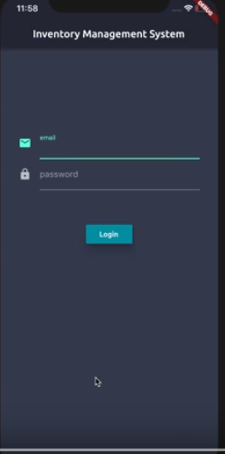 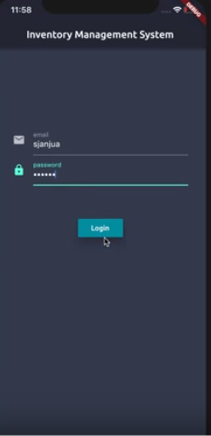

After matching user information is entered and the log in button is pressed the login screen will lead to the home screen. If there is an issue with the login information an error will be displayed, and the user can either fix the data or signup if necessary.

Home Screen

The home screen opens when a successful login screen and the first thing that a user will notice is the real-time product list that is immediately available on the home page. On the right side of each product is a color indicator with red meaning that the product needs to be restocked and yellow if otherwise. In the top left-hand corner there is a dropdown menu where other options can be accessed when the button is pressed.

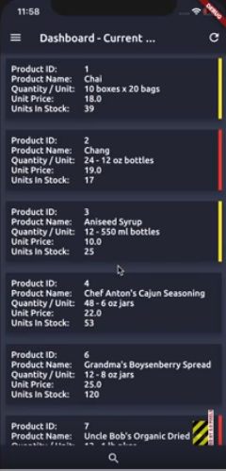 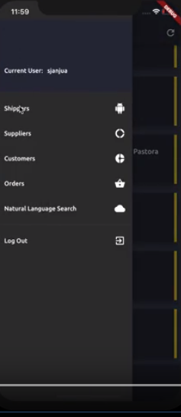

From here the user can choose any of the options on the list to proceed with their app experience. In the next few sections the options will be shown briefly.

Dashboard:

Orders

When the order page is selected from the drop down menu the user will be taken to the order page somewhat like the one shown below.

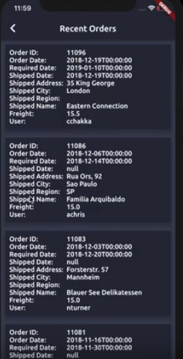

The orders and the attributes of that order are shown on individual “cards” and by either swiping up or down on the screen the orders can be viewed easily.

If the previous page is desired there is a back arrow in the top left-hand corner that can be clicked to return.

Shippers

If the shippers button is selected from the drop down menu the user will see something like the following.

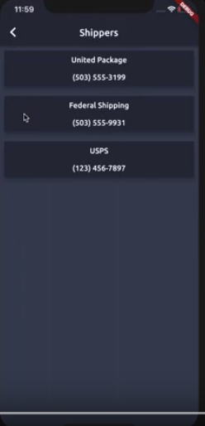

Again, there will be a return arrow in the top left-hand corner should the user decide to return to the previous page.

Shippers is not a very complicated page as it serves as a reference as each shipper only has two attributes. There attributes as seen above are shipper name and shipper phone number.

Suppliers

If the suppliers button is selected from then dashboard menu the user will be redirected to a page that looks like the following

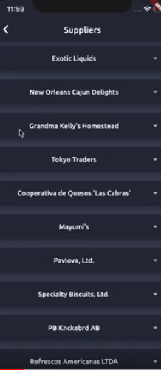 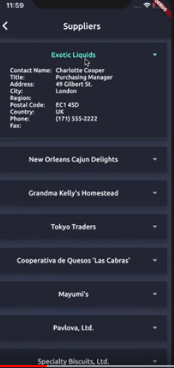 🡨 EXPANDED

When a supplier name is selected it will be expanded into a full “card” that displays the data for that supplier. It can be reselected to then recompress the card back to the name of the supplier. There is a back option at the top of the page is in the other pages before this one.

Customer

When the customer button is pressed the user will be redirected to the customer page where the user can view the customers by name and expand from the names into a full data card if necessary. Both options will be shown in the snapshots below

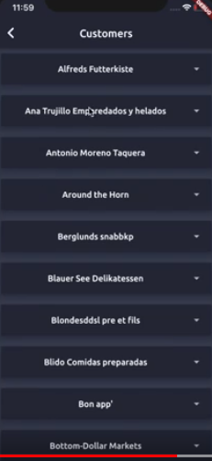 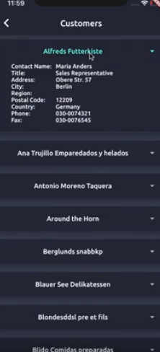

After using the customers pages the user can return to previous page using the arrow.

Natural Language Search

The natural language search is a powerful tool that can be accessed from the dashboard and upon selection takes the user to another page where they can begin to utilize the natural language search. In short natural language search allows you to search for things in the app using sentence fragments and more speech-oriented search patterns.

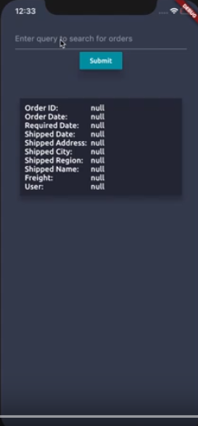

In the search bar at the top of the screen a user can begin to look for orders using the natural search that was previously mentioned.

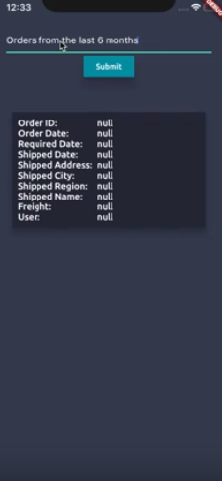 result of query🡪 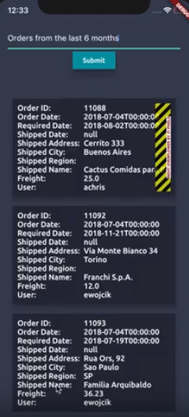

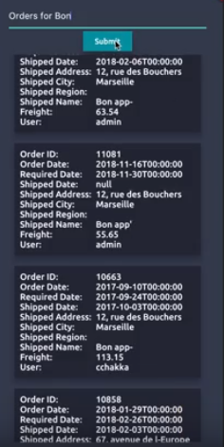 This is the result of another search using the natural language search.

User can choose to go back if they wish or try another search.

The user can log out from any of the pages and the log out buttons will either say log out or be in the form of a power icon.